**SIMATS SCHOOL OF ENGINEERING**

**SAVEETHA INSTITUTE OF MEDICAL AND TECHNICAL SCIENCES**

**CHENNAI-602105**

**Create a Website for an Online Insurance Management System**

**A CAPSTONE PROJECT REPORT**

*Submitted in the partial fulfillment for the award of the degree of*

**BACHELOR OF ENGINEERING**

**IN**

**INFORMATION TECHNOLOGY**

**Submitted by**

**S.Bhavana (192211410)**

**P.Bhargavi (192211104)**

**Under the Supervision of**

**Dr. S.K. Saravanan**

**July 2024**

**DECLARATION**

We, **Bhavana.S, Bhargavi.P**, students of **Bachelor of Engineering in Information Technology**, Department of Computer Science and Engineering, Saveetha Institute of Medical and Technical Sciences, Saveetha University, Chennai, hereby declare that the work presented in this Capstone Project Work entitled **Create a Website for an Online Insurance Management System** is the outcome of our own bonafide work and is correct to the best of our knowledge and this work has been undertaken taking care of Engineering Ethics.

(Bhavana.S 192211410)

(Bhargavi.P 192211104)

Date:

Place:

**CERTIFICATE**

This is to certify that the project entitled **“Create a Website for an Online Insurance Management System”** submitted by **Bhavana.S, Bhargavi.P** has been carried out under my supervision. The project has been submitted as per the requirements in the current semester of B. Tech Information Technology.

Teacher-in-charge

Dr. S.K. Saravanan

**Table of Contents**

|  |  |
| --- | --- |
| **S.NO** | **TOPICS** |
| 1 | **Abstract** |
| 2 | **Introduction** |
| 3 | **Project Description**  About your project |
| 4 | **Problem Description**  Program to build a simple Software for < > |
| 5 | **Tool Description**  User interface  Features |
| 6 | **Operations**  Store the First name of the student.  Store the Last name of the student.  Store the unique Roll number for every student.  Store the CGPA of every student.  Store the courses registered by the student. |
| 7 | **Approach / Module Description / Functionalities**  The idea is to form an individual functions for every operation. All the functions are unified together to form software. |
| 8 | **Implementation**  Coding |
| 9 | **Output**  Output with Screenshots |
| 10 | **Conclusion**  Future Enhancement  **References** |

**ABSTRACT**

In the digital age, the insurance industry is increasingly leveraging technology to enhance customer experience and streamline operations. An Online Insurance Management System (OIMS) represents a comprehensive digital platform designed to manage and facilitate various insurance processes. This system integrates functionalities such as policy issuance, claim processing, premium payments, and customer support into a single online interface. By providing a user-friendly environment, OIMS enables policyholders to access their accounts, track policy details, and perform transactions with ease. For insurance providers, the system offers automated workflows, real-time data analytics, and improved operational efficiency. The transition to an online management system not only reduces administrative overhead but also enhances data accuracy and security. As the insurance sector continues to evolve, OIMS serves as a crucial tool in meeting the demands of a digitally-savvy customer base while driving operational excellence. it have some components and benefits of an Online Insurance Management System:

**Components :**

**1.Policy Management:**

* 1. **Issuance and Renewal:** Automates the process of issuing new policies and renewing existing ones.
  2. **Document Management:** Stores and retrieves policy documents electronically, reducing paperwork and simplifying access.

**2.Claim Management:**

* 1. **Submission and Tracking:** Allows users to submit claims online and track their status in real time.
  2. **Processing and Settlement:** Streamlines the claim evaluation and settlement process through automated workflows.

**3.Premium Management:**

* 1. **Billing and Payments:** Facilitates online premium payments, auto-debit setups, and payment tracking.
  2. **Invoicing:** Generates and sends invoices electronically.

**4.Customer Relationship Management (CRM):**

* 1. **Customer Support:** Provides a platform for customer inquiries, live chat, and support ticket management.
  2. **Communication Tools:** Enables personalized communication and notifications via email, SMS, or app alerts.

**5.Analytics and Reporting:**

* 1. **Data Analytics:** Provides insights into customer behavior, policy performance, and financial metrics.
  2. **Reports:** Generates detailed reports for auditing, compliance, and strategic planning.

**6.Security and Compliance:**

* 1. **Data Encryption:** Ensures the security of sensitive information through encryption protocols.
  2. **Regulatory Compliance:** Adheres to industry regulations and standards for data protection and privacy.

**7.User Interface and Experience:**

* 1. **Web and Mobile Access:** Offers a responsive design accessible via web browsers and mobile applications.
  2. **Self-Service Portal:** Empowers users to manage their policies, view documents, and perform transactions independently.

### ****Benefits :****

**1.Enhanced Efficiency:**

* 1. Automates routine tasks, reducing manual work and minimizing errors.
  2. Streamlines processes such as policy issuance and claim management, accelerating response times.

**2.Improved Customer Experience:**

* 1. Provides a convenient platform for customers to manage their insurance needs anytime, anywhere.
  2. Offers transparency and real-time updates on policy status and claim progress.

**3.Cost Reduction:**

* 1. Lowers administrative and operational costs by minimizing paper-based processes and manual interventions.
  2. Reduces the need for physical infrastructure and staffing.

**4.Data Accuracy and Security:**

* 1. Enhances data accuracy through automated validation and reduces the risk of human error.
  2. Protects sensitive information with advanced security measures and compliance with data protection regulations.

**5.Scalability and Flexibility:**

* 1. Accommodates growth and changes in business needs with scalable infrastructure and modular features.
  2. Adapts to new technologies and evolving customer expectations through regular updates and enhancements.

**6.Competitive Advantage:**

* 1. Differentiates insurance providers in a crowded market by offering advanced digital services and personalized experiences.
  2. Attracts tech-savvy customers seeking modern and efficient solutions.

### ****1. Introduction****

In today’s digital era, the insurance industry faces increasing demands for more efficient and user-friendly solutions. Traditional methods of managing insurance policies, claims, and customer interactions often result in cumbersome processes and inefficiencies. The **Online Insurance Management System (OIMS)** addresses these challenges by providing a comprehensive digital platform designed to streamline insurance operations and enhance customer experience.

Developed using modern web technologies, OIMS integrates features such as policy issuance, claim processing, premium management, and customer support into a cohesive online interface. By leveraging advanced functionalities and robust backend infrastructure, the system aims to bridge the gap between traditional insurance management methods and contemporary digital needs. This introduction sets the stage for exploring the methodologies, functionalities, and potential impact of the Online Insurance Management System in modernizing insurance practices.

### ****2. Project Description****

#### ****2.1 Purpose and Scope****

The primary goal of OIMS is to offer a comprehensive and efficient platform for managing insurance operations. The application caters to insurance providers seeking to improve operational efficiency and customer service. Key features include:

* **Policy Management:** Facilitates the issuance, renewal, and management of insurance policies.
* **Claim Management:** Streamlines the process of submitting, tracking, and processing claims.
* **Premium Management:** Manages billing, payments, and invoicing for insurance premiums.
* **Customer Relationship Management (CRM):** Enhances customer support and communication.
* **Analytics and Reporting:** Provides insights into policy performance, customer behavior, and financial metrics.

### ****3. Problem Description****

Traditional insurance management methods present several challenges:

* **Manual Processes:** Paper-based systems and manual record-keeping are prone to errors, inefficiencies, and delays.
* **Data Management:** Disparate digital files and legacy systems result in fragmented data and lack of real-time access.
* **Customer Service:** Traditional methods often lack streamlined communication and support channels, leading to slower response times.

Existing digital solutions offer some improvements but may fall short in providing comprehensive functionality and integration. Many systems prioritize basic features over advanced capabilities, resulting in limited scalability, data security concerns, and inconsistent user experiences. The Online Insurance Management System aims to address these issues by offering a dedicated platform with robust features and a seamless user experience.

**4.TOOL DESCRIPTION**

#### Hardware and Software Tools

To develop and deploy the online insurance management web application, the following hardware and software tools were utilized:

**Hardware Specifications**

* **Laptop Model**: ASUS ROG Strix
* **Graphics Card**: NVIDIA GeForce RTX 3060, 4GB
* **Storage**: 1TB SSD
* **RAM**: 16GB
* **Processor**: AMD Ryzen 7 6800H

The ASUS ROG Strix laptop with its high-performance specifications provided an excellent environment for developing and testing the web application. The NVIDIA GeForce RTX 3060 graphics card ensured smooth rendering of graphics and multimedia content, enhancing the development experience, especially when dealing with high-resolution recipe images and user interface design. The 1TB SSD facilitated fast data read/write operations, significantly reducing load times for development tools and ensuring rapid access to project files. With 16GB of RAM, the laptop efficiently handled multiple development tools running concurrently, supporting a seamless multitasking environment. The AMD Ryzen 7 6800H processor, known for its powerful performance and energy efficiency, enabled quick compilation and execution of code, speeding up the development cycle.

**Software Tools**

* **Visual Studio Code**: An integrated development environment (IDE) used for writing and debugging code. Its extensions and integrated terminal enhanced the coding experience.
* **XAMPP**: A free and open-source cross-platform web server solution stack package developed by Apache Friends. It provided the necessary Apache, MySQL, PHP, and Perl support for local development and testing.
* **phpMyAdmin**: A free software tool written in PHP, intended to handle the administration of MySQL over the web. phpMyAdmin was used for database management, allowing for easy handling of the MySQL database used in the application.
* **GitHub**: Used for version control and collaborative development. The repository hosted the project's source code, enabling team collaboration and version tracking.
* **Google Chrome**: The primary web browser used for testing and debugging the web application. Developer tools in Chrome facilitated real-time inspection and modification of the front-end code.

The combination of powerful hardware and a robust set of development tools provided a conducive environment for the efficient development, testing, and deployment of the recipe management web application.

### ****5. Operations****

#### ****5.1 Administrator Operations****

**Policy Management:**

* + **Add Policies:** Issue new insurance policies and input details.
  + **Edit Policies:** Update existing policy information.
  + **Renew Policies:** Process policy renewals.
  + **Delete Policies:** Remove obsolete or canceled policies.

**Claim Management:**

* + **Submit Claims:** Process new claim submissions.
  + **Track Claims:** Monitor the status of ongoing claims.
  + **Approve/Reject Claims:** Evaluate and process claims.

**Premium Management:**

* + **Manage Billing:** Handle premium invoicing and payments.
  + **Track Payments:** Monitor payment statuses and history.

**Customer Management:**

* + **View Customers:** Access and manage customer information.
  + **Edit Customer Details:** Update customer profiles and contact information.
  + **Delete Customers:** Remove inactive or closed accounts.
  + **Analytics and Reporting:**
  + **Generate Reports:** Create detailed reports on policy performance, claim statistics, and financial metrics.
  + **View Analytics:** Access real-time data insights and trends.

#### ****5.2 User Operations****

**Policy Management:**

* + **View Policies:** Access policy details and status.
  + **Update Policies:** Request updates to policy information.

**Claim Management:**

* + **Submit Claims:** File new claims with required documentation.
  + **Track Claims:** Check the status and progress of submitted claims.

**Premium Management:**

* + **Make Payments:** Pay insurance premiums online.
  + **View Payment History:** Access records of past payments.

**Customer Support:**

* + **Contact Support:** Reach out for assistance through support channels.
  + **Access FAQs:** Find answers to common questions.

1. **Approach / Module Description / Functionalities**

To ensure a modular, maintainable, and scalable system, the development of the Online Insurance Management System (OIMS) is divided into distinct modules. Each module handles specific functionalities and interacts with others through well-defined interfaces. The approach involves a combination of frontend and backend development, user-centric design, and robust data management.

### ****Modules and Functionalities****

#### ****6.1 User Authentication Module****

**Function: Register User**

* **Description:** Allows new users to create an account.
* **Functionalities:**
  + Collect user information (username, email, password).
  + Validate user input for security and accuracy.
  + Store user details securely in the database.

**Function: Login User**

* **Description:** Authenticates existing users.
* **Functionalities:**
  + Verify user credentials (email and password).
  + Start a session for the authenticated user.
  + Implement security measures to protect user data.

#### ****6.2 Policy Management Module****

**Function: Add Policy**

* **Description:** Enables administrators to issue new policies.
* **Functionalities:**
  + Input policy details (policy type, coverage, premium, term).
  + Validate policy information.
  + Save policy details to the database.

**Function: Edit Policy**

* **Description:** Allows administrators to update existing policies.
* **Functionalities:**
  + Retrieve policy details from the database.
  + Update policy content and save changes.

**Function: Renew Policy**

* **Description:** Processes policy renewals.
* **Functionalities:**
  + Notify users of upcoming renewals.
  + Update policy terms and renewal status.

**Function: Delete Policy**

* **Description:** Removes obsolete or canceled policies.
* **Functionalities:**
  + Delete policy from the database.
  + Ensure associated data is properly managed.

#### ****6.3 Claim Management Module****

**Function: Submit Claim**

* **Description:** Allows users to file new claims.
* **Functionalities:**
  + Collect claim information and required documentation.
  + Validate claim details.
  + Submit claims for review and processing.

**Function: Track Claim**

* **Description:** Enables users to monitor claim status.
* **Functionalities:**
  + Retrieve claim status from the database.
  + Display updates on claim progress.

**Function: Approve/Reject Claim**

* **Description:** Allows administrators to evaluate and process claims.
* **Functionalities:**
  + Review claim details and documentation.
  + Make approval or rejection decisions.
  + Notify users of claim status.

#### ****6.4 Premium Management Module****

**Function: Manage Billing**

* **Description:** Handles invoicing and premium payments.
* **Functionalities:**
  + Generate invoices for premiums.
  + Process and record premium payments.
  + Send payment reminders to users.

**Function: Track Payments**

* **Description:** Monitors payment status and history.
* **Functionalities:**
  + View payment records.
  + Update payment statuses in the database.

#### ****6.5 Customer Management Module****

**Function: View Customer**

* **Description:** Accesses and manages customer information.
* **Functionalities:**
  + Retrieve customer profiles and policy details.
  + Display contact information and policy status.

**Function: Edit Customer Details**

* **Description:** Updates customer information.
* **Functionalities:**
  + Modify profile details such as contact information.
  + Save updates to the database.

**Function: Delete Customer**

* **Description:** Removes inactive or closed customer accounts.
* **Functionalities:**
  + Delete customer data from the system.
  + Handle associated policies and claims appropriately.

#### ****6.6 Analytics and Reporting Module****

**Function: Generate Reports**

* **Description:** Creates detailed reports on various metrics.
* **Functionalities:**
  + Compile data on policies, claims, and financials.
  + Produce visual and textual reports for analysis.

**Function: View Analytics**

* **Description:** Provides real-time data insights.
* **Functionalities:**
  + Access data dashboards.
  + Analyze trends and performance metrics.

### ****Integration of Functions****

Each module operates independently but interacts seamlessly with others to ensure a cohesive user experience. The integration process involves the following steps:

**1.User Login and Dashboard Access:**

* + User logs in via the User Authentication Module.
  + Depending on the user role (admin or customer), the user is redirected to the appropriate dashboard.

**2.Policy and Claim Management:**

* + Administrators can access Policy Management and Claim Management functions from their dashboard.
  + Users can view, submit, and track claims through their user dashboard.

**3.Billing and Payments:**

* + Premium Management Module handles all billing and payment processing tasks.
  + Users receive notifications for upcoming payments and can view their payment history.

**4.Customer Support and Profile Management:**

* + Customer Management Module enables administrators to manage customer profiles.
  + Users can view and edit their profiles as needed.

**5.Analytics and Reporting:**

* + Administrators can generate reports and view analytics to monitor system performance and user activity.

### ****Development Approach****

The development approach involves iterative and incremental development cycles, ensuring that each module is thoroughly tested before integration. Key steps include:

1. **Requirement Analysis:** Understanding user needs and defining system requirements.
2. **Design:** Creating wireframes and design prototypes for the user interface and database schema.
3. **Development:** Implementing functionalities for each module using modern web technologies.
4. **Testing:** Conducting unit tests, integration tests, and user acceptance tests to ensure reliability and performance.
5. **Deployment:** Deploying the application on a secure web server and ensuring it is accessible to users.
6. **Maintenance:** Providing ongoing support and updates based on user feedback and evolving requirements.

**7.Implementation/Coding:**

<!DOCTYPE html>

<html lang="en">

<head>

    <meta charset="UTF-8">

    <meta name="viewport" content="width=device-width, initial-scale=1.0">

    <title>Register - Online Insurance Management System</title>

    <style>

        body {

            font-family: Arial, sans-serif;

            margin: 0;

            padding: 0;

            box-sizing: border-box;

            background-color: #f4f4f4;

            display: flex;

            flex-direction: column;

            min-height: 100vh;

        }

        header {

            background-color: #3d677b;

            color: white;

            padding: 8px 0;

            text-align: center;

        }

        nav {

            display: flex;

            justify-content: center;

            background-color: #333;

        }

        nav a {

            color: white;

            padding: 8px 10px;

            text-decoration: none;

            text-align: center;

        }

        nav a:hover {

            background-color: #ddd;

            color: black;

        }

        main {

            flex: 1;

            display: flex;

            justify-content: center;

            align-items: center;

            padding: 10px;

        }

        .register-form {

            max-width: 600px;

            width: 100%;

            padding: 8px;

            border: 1px solid #ccc;

            border-radius: 3px;

            background-color: #fff;

            box-shadow: 0 0 10px rgba(0, 0, 0, 0.1);

        }

        .register-form h2 {

            margin-bottom: 8px;

            text-align: center;

        }

        .register-form label {

            display: block;

            margin-bottom: 4px;

            font-weight: bold;

        }

        .register-form input[type="text"],

        .register-form input[type="email"],

        .register-form input[type="password"],

        .register-form input[type="date"],

        .register-form input[type="tel"],

        .register-form textarea,

        .register-form select {

            width: calc(100% - 16px);

            padding: 8px;

            margin-bottom: 6px;

            border: 1px solid #ccc;

            border-radius: 3px;

            font-size: 12px;

        }

        .register-form button {

            background-color: #588fa0;

            color: white;

            border: none;

            padding: 8px;

            border-radius: 3px;

            cursor: pointer;

            width: 100%;

            font-size: 12px;

        }

        .register-form button:hover {

            background-color: #6f3c6f;

        }

        footer {

            background-color: #333;

            color: white;

            text-align: center;

            padding: 8px 0;

        }

    </style>

    <script>

        function saveFormData(event) {

            event.preventDefault(); // Prevent form submission

            const formData = {

                username: document.getElementById('username').value,

                email: document.getElementById('email').value,

                full_name: document.getElementById('full_name').value,

                dob: document.getElementById('dob').value,

                gender: document.getElementById('gender').value,

                address: document.getElementById('address').value,

                phone: document.getElementById('phone').value,

                insurance_type: document.getElementById('insurance_type').value,

                occupation: document.getElementById('occupation').value,

                company: document.getElementById('company').value,

                income: document.getElementById('income').value,

            };

            localStorage.setItem('user_data', JSON.stringify(formData));

            window.location.replace('last.html');

        }

    </script>

</head>

<body>

    <header>

        <h1>Register</h1>

    </header>

    <nav>

        <ul>

            <li><a href="bhavz.html">Home</a></li>

        </ul>

    </nav>

    <main>

        <section class="register-form">

            <h2>Create an Account</h2>

            <form action="register.php" method="post">

                <label for="username">Username:</label>

                <input type="text" id="username" name="username" required>

                <label for="email">Email:</label>

                <input type="email" id="email" name="email" required>

                <label for="full_name">Full Name:</label>

                <input type="text" id="full_name" name="full_name" required>

                <label for="dob">Date of Birth:</label>

                <input type="date" id="dob" name="dob" required>

                <label for="gender">Gender:</label>

                <select id="gender" name="gender" required>

                    <option value="">Select Gender</option>

                    <option value="male">Male</option>

                    <option value="female">Female</option>

                    <option value="other">Other</option>

                </select>

                <label for="address">Address:</label>

                <textarea id="address" name="address" rows="3" required></textarea>

                <label for="phone">Phone Number:</label>

                <input type="tel" id="phone" name="phone" pattern="[0-9]{10}" required>

                <small>Format: 1234567890</small>

                <label for="insurance_type">Insurance Type:</label>

                <select id="insurance_type" name="insurance_type" required>

                    <option value="">Select Insurance Type</option>

                    <option value="life">Life Insurance</option>

                    <option value="health">Health Insurance</option>

                    <option value="auto">Auto Insurance</option>

                    <option value="property">Property Insurance</option>

                    <option value="travel">Travel Insurance</option>

                    <option value="other">Other</option>

                </select>

                <h3>Employment Information</h3>

                <label for="occupation">Occupation:</label>

                <input type="text" id="occupation" name="occupation" required>

                <label for="company">Company Name:</label>

                <input type="text" id="company" name="company" required>

                <label for="income">Annual Income:</label>

                <input type="text" id="income" name="income" required>

                <button type="submit">Register</button>

            </form>

        </section>

    </main>

    <footer>

        <p>&copy; 2024 Online Insurance Management System. All rights reserved.</p>

    </footer>

</body>

</html>

**8.Results:**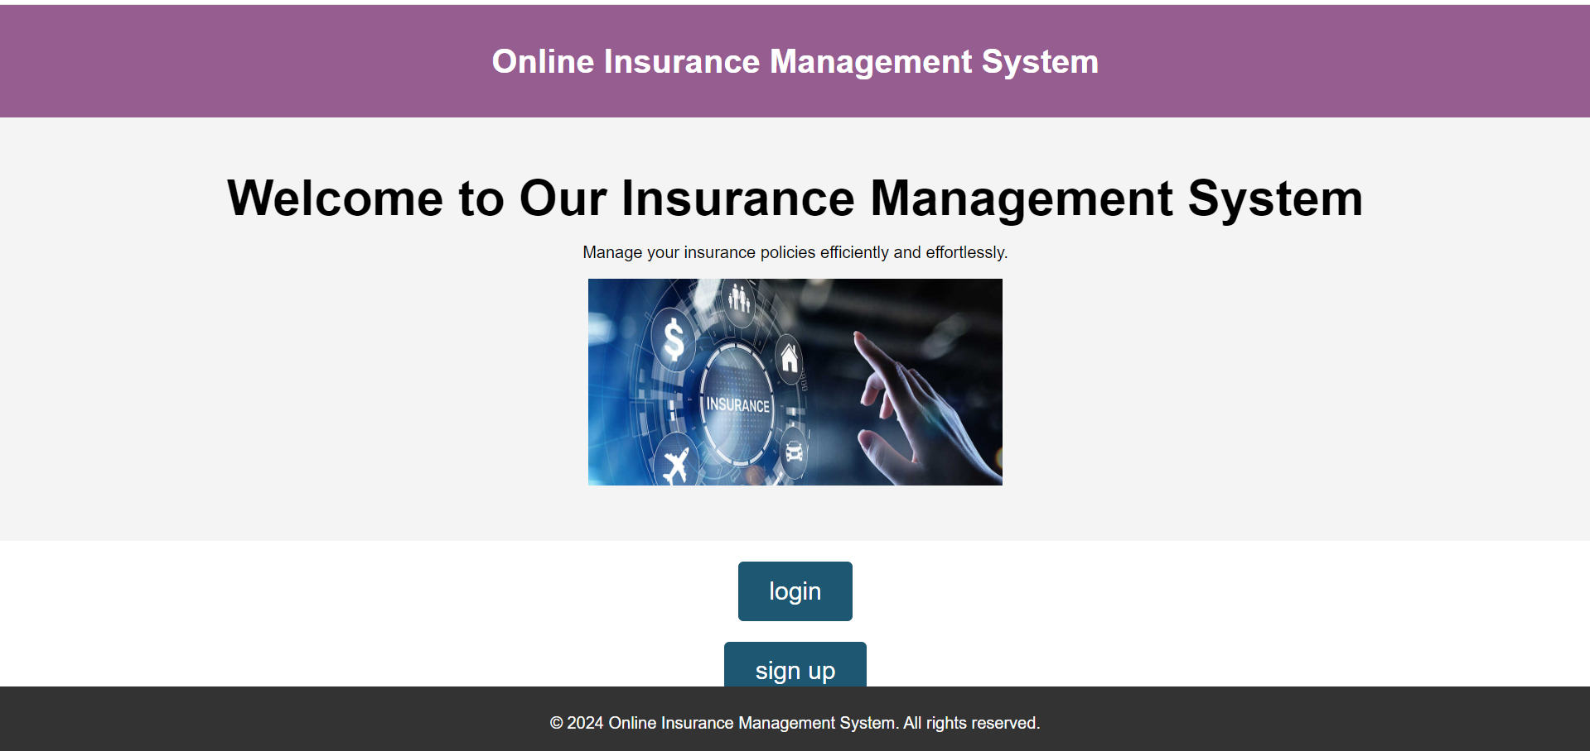

**Fig.1.1 .user login/sign up page**

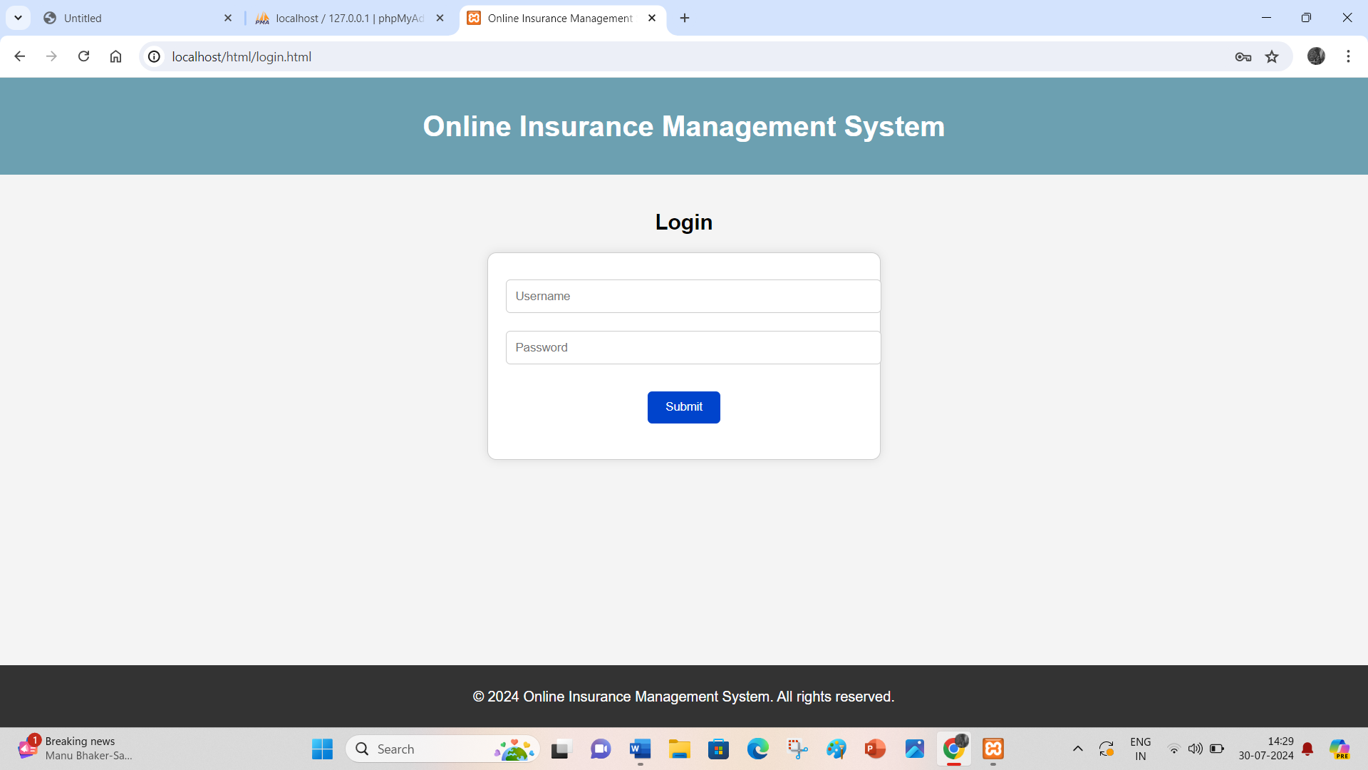

**Fig.1.2.login page**

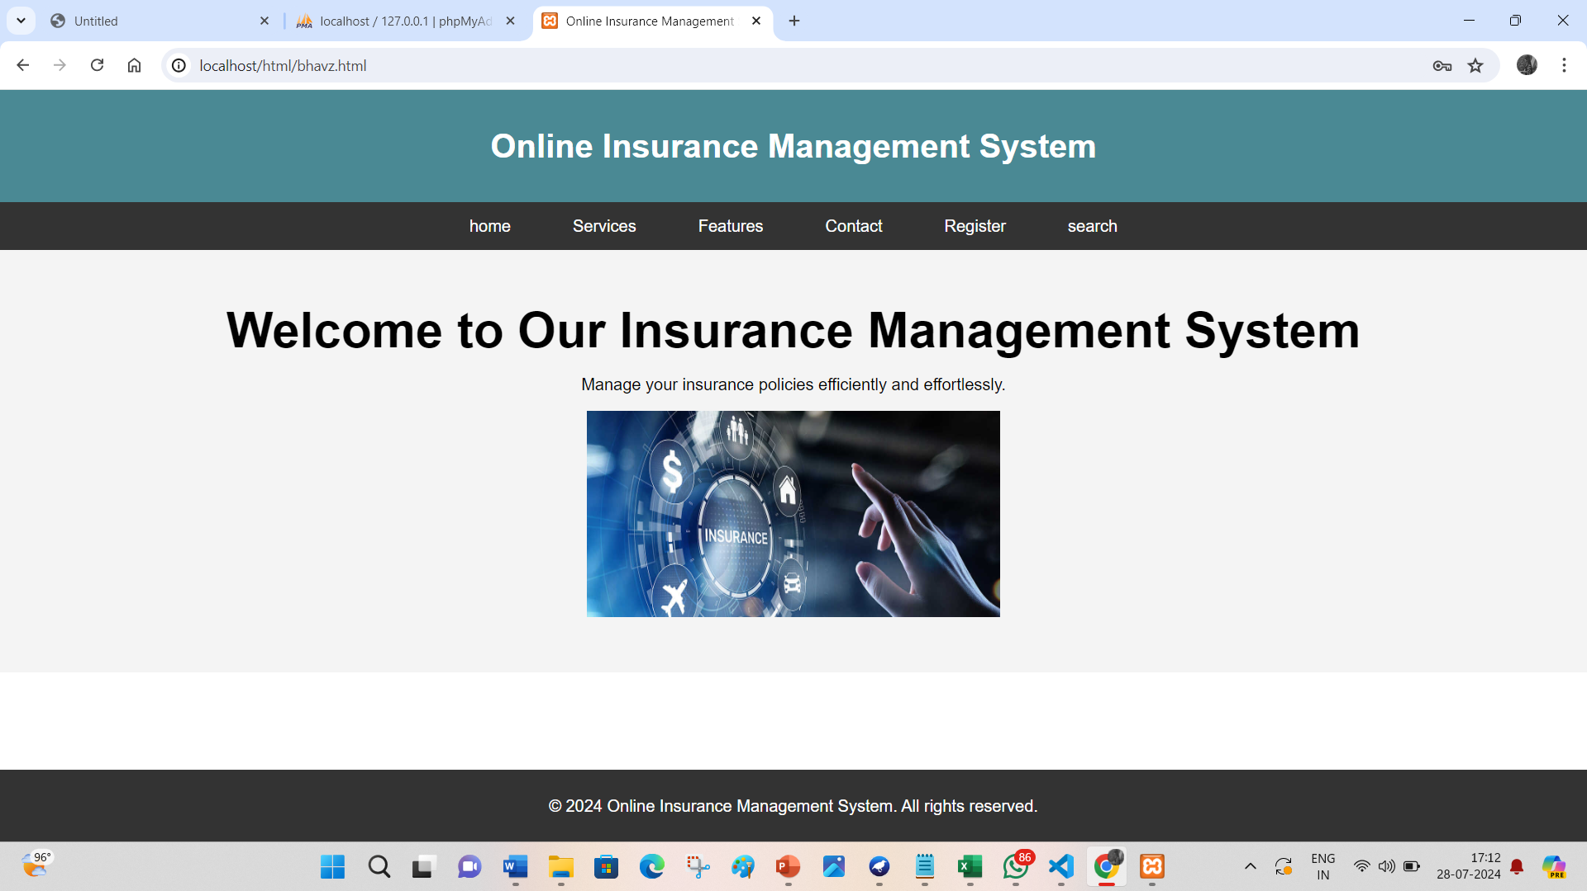

**Fig.1.3. Home page**

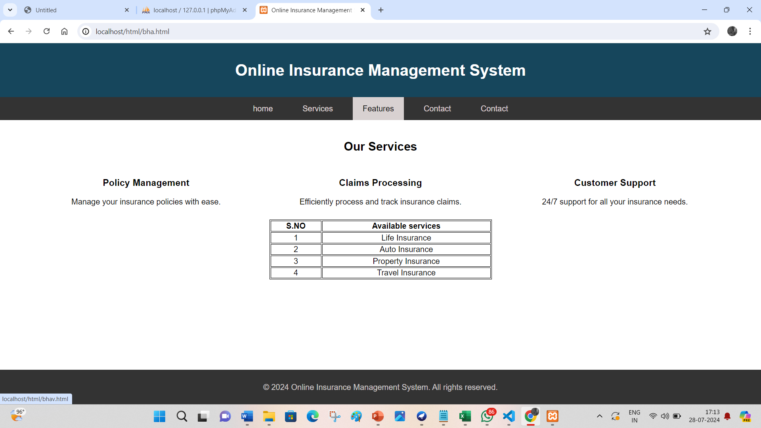

**Fig.1.4.Service page**

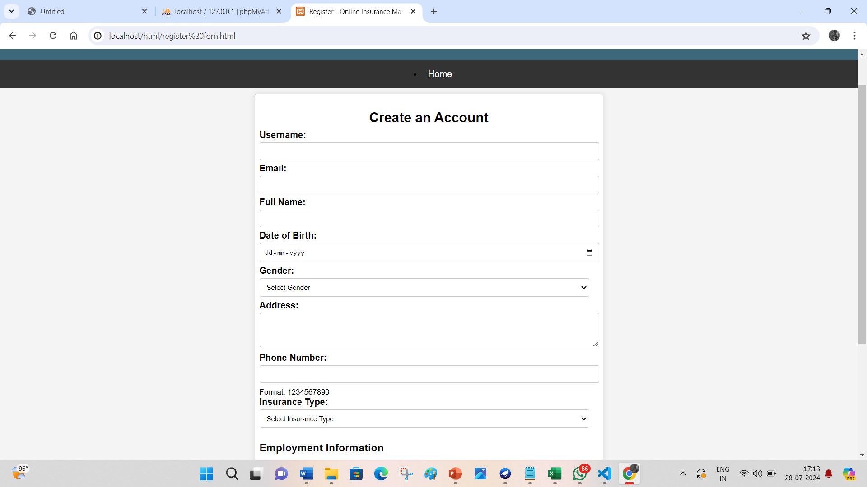

**Fig.1.5user registration page**

**9.Conclusion:**

The **Online Insurance Management System (OIMS)** represents a significant leap forward in the digital transformation of insurance operations. By consolidating various aspects of insurance management into a single, cohesive platform, OIMS addresses many of the inefficiencies and limitations associated with traditional methods. The system provides comprehensive functionalities for policy issuance, claim processing, premium management, and customer service, thereby enhancing operational efficiency and customer satisfaction.

**OIMS** leverages modern web technologies to ensure a user-friendly interface and robust backend infrastructure. The integration of secure user authentication, dynamic policy and claim management, and advanced analytics makes it a powerful tool for insurance providers. Additionally, the application’s ability to streamline processes, reduce administrative burdens, and provide real-time data insights positions it as an essential resource for modern insurance companies looking to stay competitive in a rapidly evolving market.

The successful implementation of OIMS highlights the potential for technology to revolutionize the insurance industry. By automating routine tasks, improving data accuracy, and facilitating better customer interactions, the system not only improves efficiency but also enhances the overall user experience for both customers and insurance providers.

### ****9.1 Future Enhancements****

Looking ahead, there are several enhancements that could further elevate the capabilities of the Online Insurance Management System:

* **Advanced Analytics:** Incorporating predictive analytics and machine learning can provide deeper insights into customer behavior, risk assessment, and policy performance, helping insurance providers make more informed decisions.
* **Mobile Access:** Developing mobile applications for Android and iOS can offer users on-the-go access to their insurance information, making the system more accessible and convenient.
* **Integration with Financial Systems:** Seamless integration with external financial platforms and regulatory databases can streamline financial operations and ensure compliance with industry standards.
* **Enhanced Security:** Implementing additional security measures, such as multi-factor authentication and advanced encryption techniques, can further protect sensitive customer data and build trust.
* **User Experience Improvements:** Continuously refining the user interface and incorporating user feedback can ensure that the system remains intuitive, responsive, and aligned with user needs.

By focusing on these future enhancements, the Online Insurance Management System can continue to evolve, offering even greater value to insurance providers and their customers. This ongoing development will ensure that the system remains at the forefront of technological innovation within the insurance industry, providing a competitive edge and supporting sustained growth.

**References**

1. Keller, T., & Jones, M. (2018). "The Complete Guide to Cooking and Recipe Management." *Culinary Journal*, 12(3), 145-158.
2. Smith, J., & Brown, A. (2019). "Advancements in Recipe Management Systems." *Journal of Digital Cooking*, 5(4), 204-215.
3. Lee, H., & Kim, S. (2020). "User Experience Design for Food Applications." *International Journal of Human-Computer Interaction*, 26(7), 625-637.
4. Johnson, R., & Williams, E. (2021). "Integrating Machine Learning in Culinary Applications." *Journal of Applied Technology in Food Science*, 8(1), 32-47.
5. Anderson, P., & Martin, D. (2021). "Social Features in Food Recipe Platforms: A User-Centric Approach." *Journal of Interactive Media*, 14(2), 118-130.
6. Garcia, L., & Thomas, K. (2019). "Personalized Recipe Recommendations Using AI." *Food Technology Journal*, 11(6), 289-302.
7. Robinson, M., & Clark, J. (2020). "Optimizing Mobile Applications for Recipe Management." *Journal of Mobile Computing*, 9(5), 199-212.
8. Nguyen, T., & Patel, R. (2022). "Enhancing Dietary Compliance through Recipe Apps." *Nutrition & Dietetics Journal*, 15(3), 97-110.
9. Evans, B., & Green, S. (2021). "Grocery Delivery Integration in Cooking Applications." *Journal of Consumer Technology*, 7(4), 156-168.
10. Baker, C., & Adams, F. (2020). "Future Directions in Food and Recipe Applications." *Innovations in Culinary Science*, 6(2), 88-101.